**PSY 653 Module 2: Interaction Effects in Regressions**

**Feb 05, 2020**

*Part 1: In-Class Demo*

Follow along as we talk through the steps of conducting a moderated regression. We will use the datafile “moderation_demo.csv” for this exercise, which includes simulated data. We will conduct a regression in which att1, att3, and the cross product of att1 & att3 are examined as predictors of out4.

1. Create a new R notebook and load the following libraries: psych, tidyverse, and olsrr
2. Read in the datafile “moderation_demo.csv” and get variable descriptives
3. Calculate and interpret the correlation between att3 and att1. Does the correlation suggest that there is room for a moderation effect?
4. Use the mutate() function to create a new variable that is the cross product of att1 and att3
5. Run a main effects model in which att1 and att3 are examined as predictors of out4
   1. Interpret this model output, including the model R² and the slopes, std. betas, and significance of each predictor
6. Run the same model, but this time also include the cross product of att1 & att3 (i.e., the interaction term for these two variables) as a predictor of out4
   1. Interpret this model output, including the model R² and the slopes, std. betas, and significance of each predictor and the interaction term
7. Use the anova() function to compare the fit of the two models (hint: think hierarchical regression)
   1. Does adding the interaction term significantly improve model fit?

*Part 2: Try It Yourself*

Use the “moderation_sleepdata.csv” datafile to practice conducting a moderated regression on your own. This datafile includes data from 600 adult participants who were suffering from a sleep disorder. You will examine how sleep hygiene (variable name = *hygiene*), reported anxiety levels (variable name = *anxiety*), and the interaction between sleep hygiene and anxiety predict sleep efficiency (variable name = *sleep*).

1. Read in the datafile “moderation_sleepdata.csv” and get data descriptives

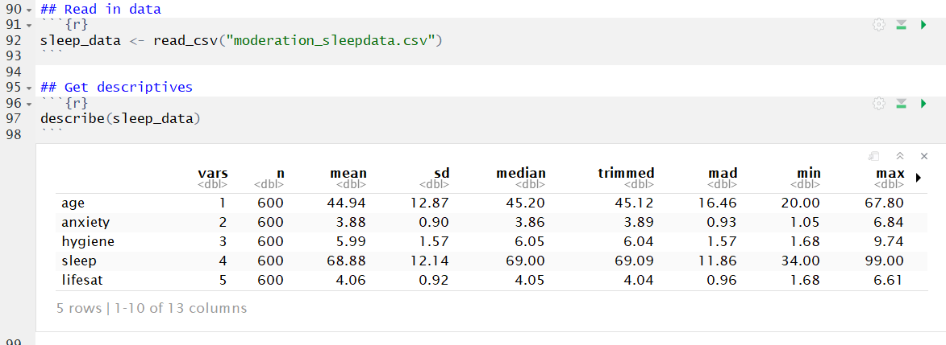

1. Calculate and interpret the correlation between hygiene and anxiety

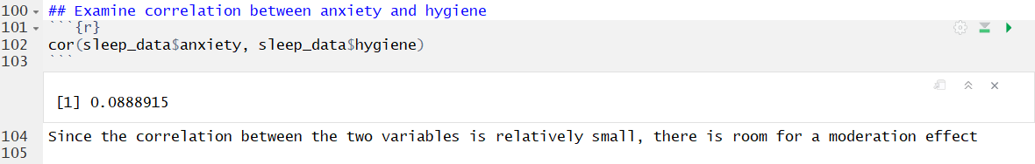

1. Create a new variable for the cross-product of hygiene and anxiety



1. Run a regression to test the main effects of hygiene and anxiety on sleep and interpret the model results

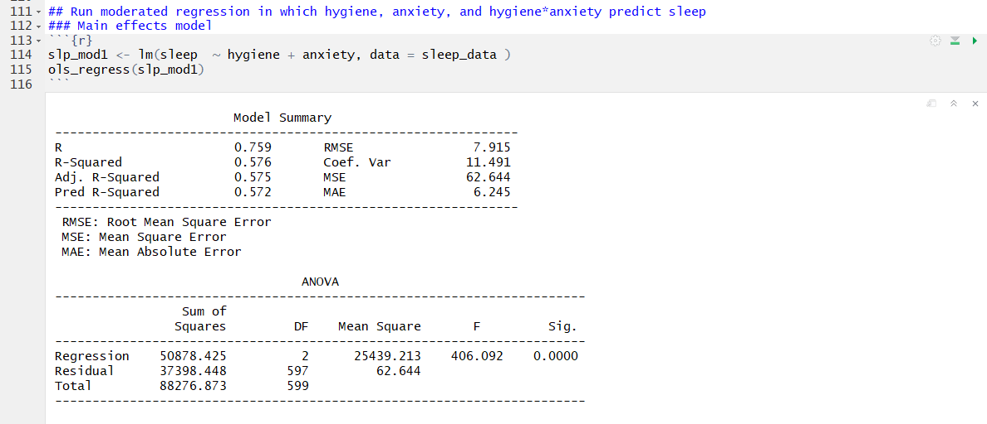

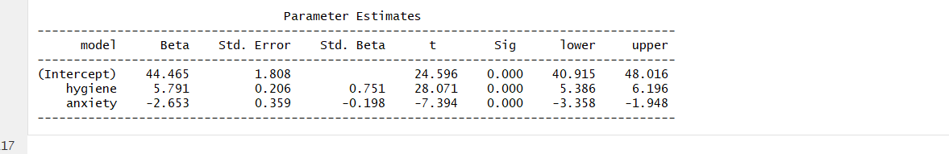

**Interpretation**: When hygiene and anxiety are zero, the expected sleep efficiency is 44.465. Holding anxiety constant, for every one-unit increase in hygiene, there is an expected 5.791 unit increase in sleep efficiency. Lastly, while holding hygeine constant, for every one-unit increase in anxiety, there is an expected 2.653 unit decrease in sleep efficiency.

1. Run the same regression that also includes the interaction term between hygiene and anxiety and interpret the model results

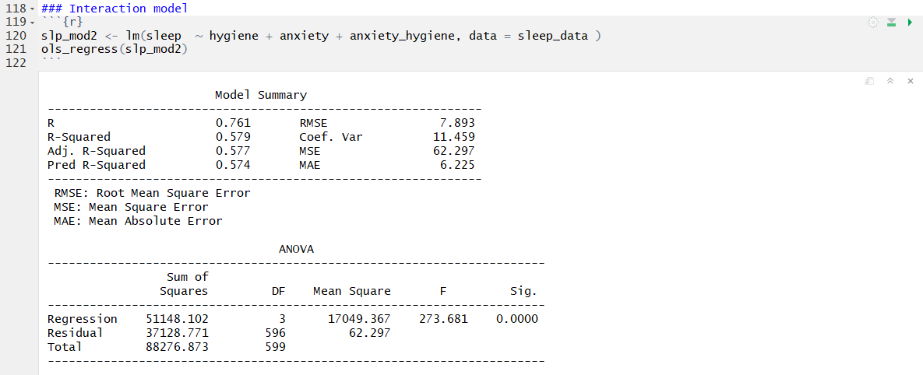

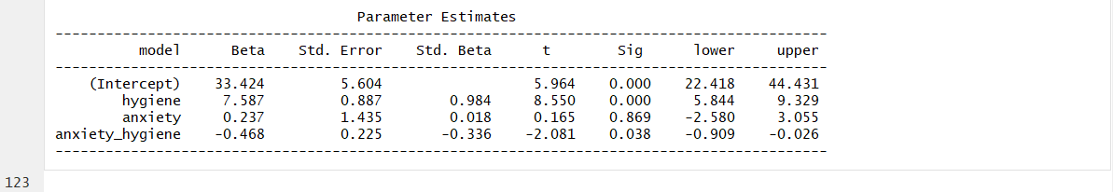

1. Compare the fit of the two models and interpret these results

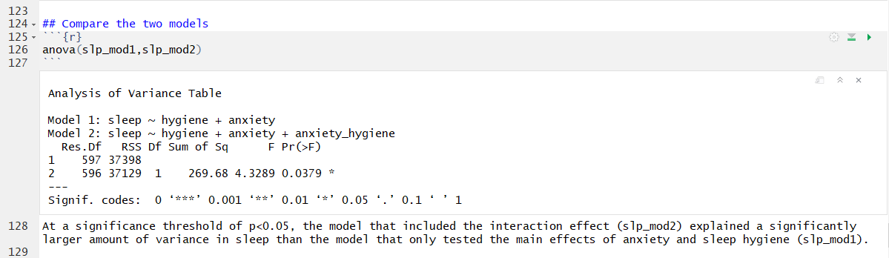

1. Write this set of results up the way you would for an APA journal

The differential effect of hygiene on sleep, using anxiety as a moderator, was examined among 600 participants. A moderation model was estimated using a regression with hygiene, anxiety, and the interaction between the two predicting sleep. The simple slope of hygiene was statistically significant (b = 7.587, 95%CI 5.844, 9.329). The simple slope of anxiety was not statistically significant (b = 0.237, 95%CI -2.580, 3.055). The interaction term is statistically significant (b = -0.468, 95%CI -0.909, -0.026).